Get SoundCard IDs vi
- Get the sound card ID with soundcard name and soundcard Mode (WDM/ASIO/WASAPI)


Input:
Soundcard Type(String):
- Input
- Output
- Loopback
- ASIO Input
- ASIO Output
- Record (WASAPI)
- Play(WASAPI)
Soundcard Name (Array): Name of soundcard

Output:
Soundcard ID (array Int): Device IDs for soundcard
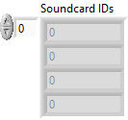
Devices Info (cluster): contain soundcard detail info
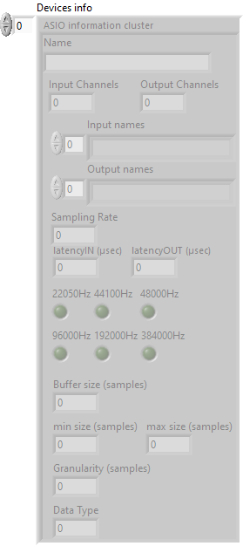

Front Panel:
