Read SoundCard Calibration vi
- Import Calibration data from the Calibration process (Calibrations.ini)
- Calibration data included: Input & output peak value, Amp Gain, and Microphone Sensitivity

Calibration.exe: Application to get and store calibration values into Calibrations.ini
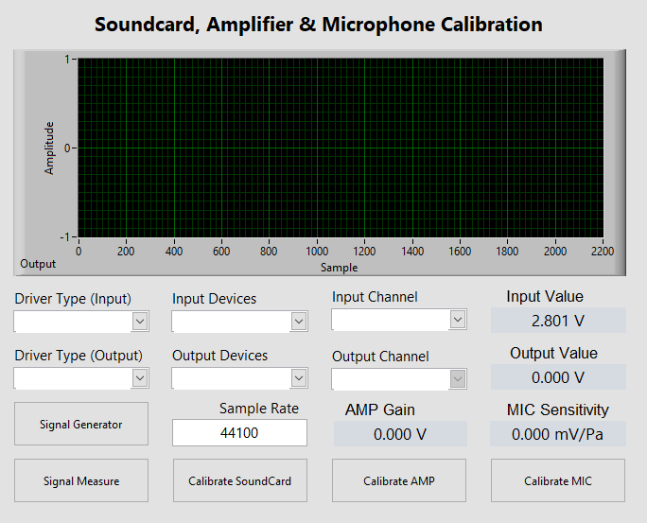
Output from Calibration exe: Calibrations.ini
[Input]
Microphone (USB Advanced Audio Device) L = 1
Microphone (USB Advanced Audio Device) R = 1

[Output]
Speakers (USB Advanced Audio Device) L = 1.092
Speakers (USB Advanced Audio Device) R = 1.092

[Amp]
Speakers (USB Advanced Audio Device) - Amp L = 6.32
Speakers (USB Advanced Audio Device) - Amp R = 6.32

[Mic]
Microphone (USB Advanced Audio Device) - Mic L = 1
Microphone (USB Advanced Audio Device) - Mic R = 1

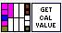
Input:
In/Out (string): Select input or output
Soundcard Type (string): select the type of soundcard driver (WDM/MME, ASIO)
Soundcard Name (string): soundcard name
Selected Channel (int): channel number
Channel Name (string Array): for WDM/MME soundcard, the name will be L or R, for ASIO soundcard, the channel name can be retrieved from the soundcard info (input name or output name)

Output:
Output Calibration (Cluster):
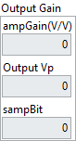
Input Calibration (Cluster):
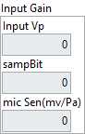

Front Panel:
