Analyze-tone vi
- Analyze Tone signal for Frequency, Amplitude & THD

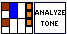
Input:
signal in (waveform): recorded waveform input
Input Calibration: Calibration value for input channel
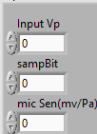
Units: Units for output data (dBPa, dBSPL)

Output:
Detected frequency: Analyzed signal frequency
Detected amplitude: analyzed signal amplitude
THD: analyzed signal THD

Front Panel:
