Analyze vi
- Extract FR, phase, THD data from recorded-Y data & Stimulus-Y data
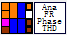
Input:
Unit (int) : or
Stimulus-Y (array double) : Y data extracted from Stimulus
Recorded-Y (array double) : Y data extracted from Recorded waveform
Sampling rate (int)
Signal config (cluster) :
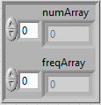

Input config (cluster) : soundcard & microphone calibration info
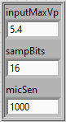
Method (int) : or
Maximum Harmonic (int) : Max harmonic for THD calculation

Output:
freqArray (array double) : frequency data point
fundamental (cluster) : unsmooth frequency response & phase curve
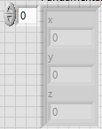
THD (cluster) : THD curve
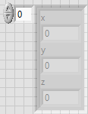

Front Panel :
