FindHead vi
- Detecting and remove the head tone added during the stimulus process before analysis process
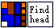
Input:
Stimulus in (waveform array) :
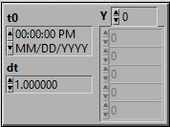

Waveform in (array double) : recorded waveform Y data
Sampling rate (int) : audio sampling rate
HeadLength (int) : number of data point of head
Method : method use to allocate the start point (or )

Output:
Chopped wavelength (int) : total number of data points after chop
Chopped waveform (array double) : chopped waveform Y data
Stimulus out (array double) : waveform Y data after removing head data
Chopped portion (waveform) : chopped head data
Stimulus out (waveform) : Stimulus data after removing head data
Start point (int) : index for new starting point

