Play vi
- Play signal in at selected soundcard and channel. The vi allows you to play a stereo, left or right channel.
- Signal in data was generated from stimulus vi

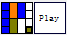
Input:
Soundcard Type :
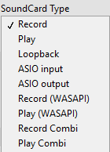
Soundcard id(output) (int): Device id for soundcard
play channel (int): set the output channel number
pre-play delay(mS) (int): delay in milliseconds added before stimulus begin
Format (cluster): Soundcard format
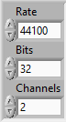
Buffer (Cluster): soundcard buffer setting
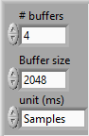
signal in (double array): array of Y value extracted from stimulus signal

Front Panel:
