Record-ASIO vi
Recording via ASIO for multi-channel soundcard

Input:
Soundcard In (cluster): support multichannel recording up to max of soundcard input
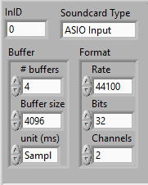
recordDuration (double): total duration for record
recordChannels (int): quantity of recording channel
Ref Mic settings (cluster): Enable only if there are ref mic connected
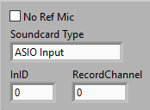

Output:
recorded waveform (array waveform): recorded DUT waveform
recorded waveform (Ref Mic) (array waveform): Recorded Ref Mic waveform

Front Panel:
