calcSensitivity vi
- Calculate the sensitivity value within the frequency range
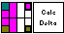
Input:
Frequency range (Cluster):
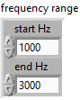
Frequency (Double Array): Frequency data
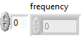
Magnitude (Double Array): Level data
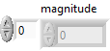

Output:
Sensitivity (Numeric): value of Sensitivity

Front Panel:
