curvenaming vi
- Automatically name input data for the Mic test or Speaker test.
- Mic test naming will start from Mic[1…n]
- Speaker test will naming with Left[1…n] & Right[1…n]
- If Ref mic enabled, the curve name with Ref Mic will be added into the output
- GS/DUT will add the GS/DUT into the curve name
Naming format:-
FR - Fundamental GS Mic1
FR - Fundamental GS Mic2
FR - Fundamental GS Mic3
FR - Fundamental GS Mic4
FR - Smoothed GS Mic1
FR - Smoothed GS Mic2
FR - Smoothed GS Mic3
FR - Smoothed GS Mic4
FR - Fundamental DUT Mic1
FR - Fundamental DUT Mic2
FR - Fundamental DUT Mic3
FR - Fundamental DUT Mic4
FR - Smoothed DUT Mic1
FR - Smoothed DUT Mic2
FR - Smoothed DUT Mic3
FR - Smoothed DUT Mic4THD - DUT Mic1
THD - DUT Mic2
THD - DUT Mic3
THD - DUT Mic4

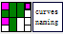
Input:
Mic? (Boolean): define if this is mic test or speaker test
Ref Mic (Boolean): enable if the ref mic data was recorded
dBSPL? (Boolean): Value convert to dB SPL (re to 20u) instead of dB V (re to 1)
GS? (Boolean): define if this is GS or DUT data
DUT Curve in (Cluster):
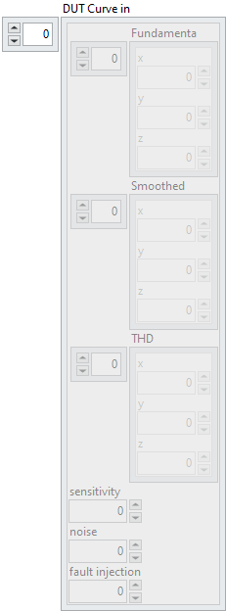
Ref Mic Curve Data (Cluster):
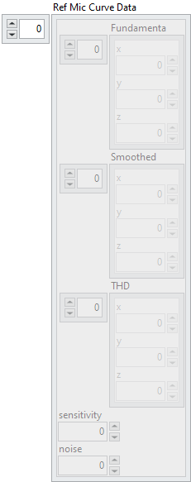

Output:
Curve out (Cluster):
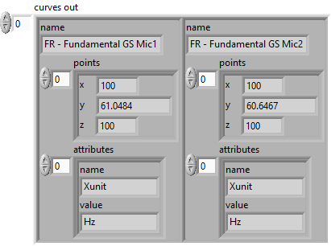
Front Panel:
