Footswitch vi
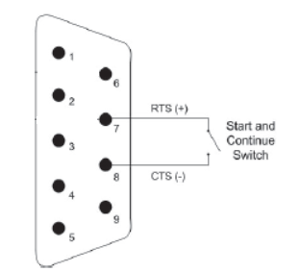
- Read state from Serial port – Pin8 (CTS).
- State Asserted will be set to Serial Port – Pin7.
- Asserted = Connected, Unasserted = Disconnected

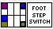

Input:
Visa resource name = Serial port number
State in = Set detected state to continue the test

Output:
State out = detected state out

