http handler

http://(DUT IP):1200/operation/[CMD]

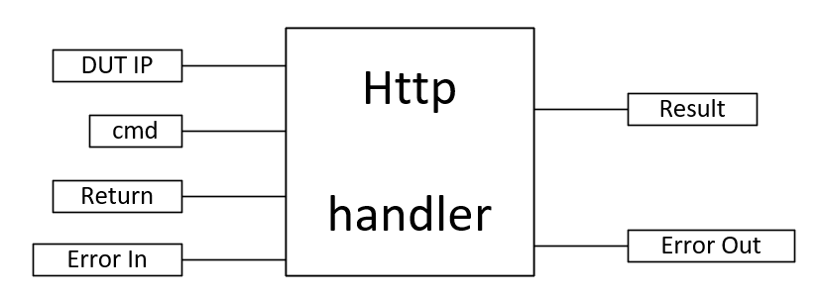

Input:
DUT IP (str) : DUT IP address. eg : 169.254.1.1
cmd (str) : http handler string after /operation/ [getflow, getmode]
Return (str) : String to compare with http return value
Output:
Result : Verdict of http return value matching with Return(str)

