limits vi
- Plot DUT FR data against limit windows for verdict

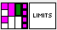

Input:
Curve in (Cluster):
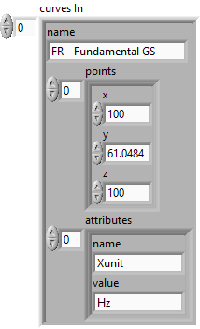
Limits (Cluster):
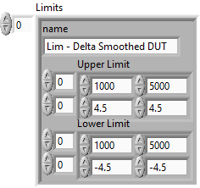
Windowing (Cluster):
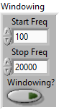

Output:
Overall result (Boolean): overall result output
Output curve (Cluster):
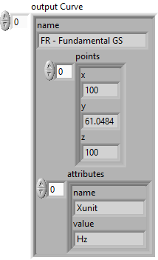
Results (Cluster):
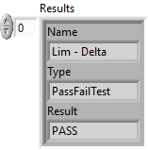
Curve Name (out) (String Array):
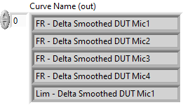

Front Panel:
