relaycontrol vi
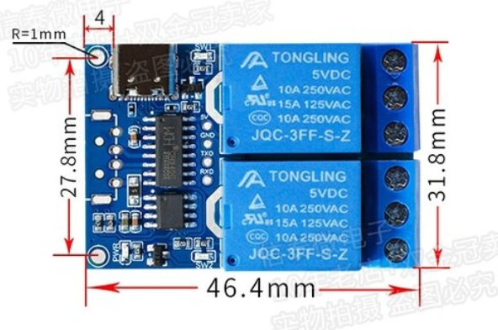
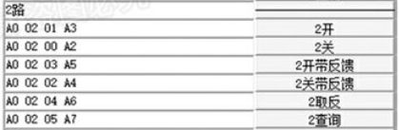
- 2 channels serial port relay board control

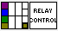
Input:
Visa resource name = Serial port number
Relay num(Int): Relay number selection
Relay On/Off (Boolean) = True = ON, False = Off

Output:
State out = detected state out

Front Panel:
