smoothing vi
- Detecting resolution of input data and apply smoothing according to the setting.

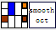
Input:
Smoothing Width (Numeric):
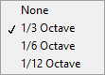
Fundamental (Cluster):
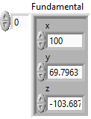

Output:
Y Out (Double Array): Smoothed Y data
Smoothed (Cluster): Smoothed Curve Data
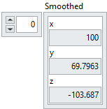

Front Panel:
