stepsweep_stimulus vi
- Generate step sweep with or without head signal. Provide duration, frequency array, data num array, and head length info needed for analysis process
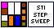
Input:
Signal config (Cluster):
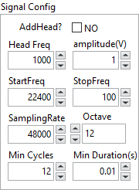
Calibration (Cluster): soundcard & amp calibration value to adjust waveform amplitude
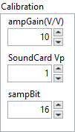

Output:
Waveform out (waveform)
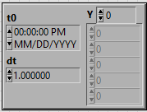
numArray (Double Array): number of data for each frequency point
freqArray (Double Array): freq table that is used to generate step sweep
duration (double): stimulus duration
headlength (double): data length info for head tone

Front Panel :
