generatelimit vi
- Generate limit curve with provided input curve data, limits name, upper limit, and lower limit
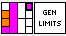

Input:
Limits Name (String): Curve name for Limit curve without the “Lim – “
Curve input (Cluster):
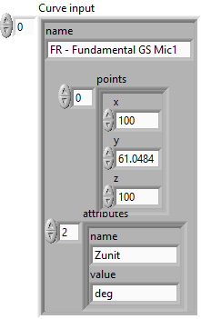
Upper Limits (Double Array):
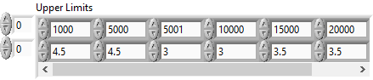
Lower Limits (Double Array):
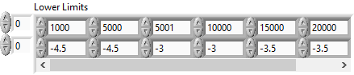

Output:
Limit curve output (Cluster):
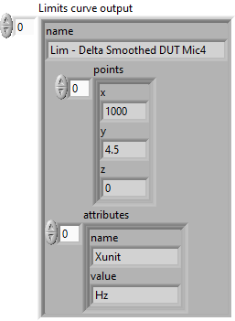

Front Panel:
