jsonlog vi
- Generate Sonos Json log format with Curve & Results data
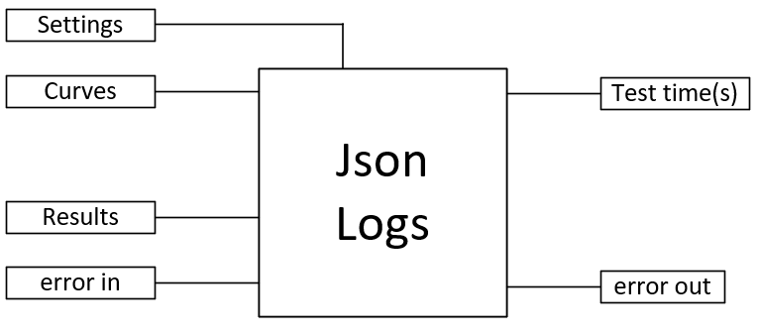

Input:
Settings (cluster) :
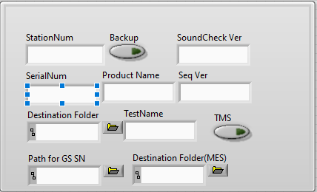

Curves (cluster) :
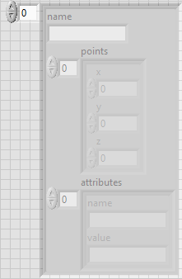

Results (cluster) :
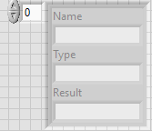

Output:
Test time(s) (double) : display total test time

Front Panel :
