importconfig vi
- Generate Sonos Json log format with Curve & Results data
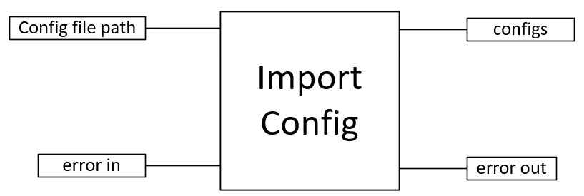

Input:
Config file path (path) : full path of the config file

Output:
Configs (cluster) : contain multiple cluster

Front Panel :
