curvesubstract vi
- Operand A – Operand B = Output

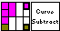

Input:
Operand A (String): Curve Name
Operand B (String): Curve Name
Output Name (String): Subtracted Curve Name
Input curve (Cluster):
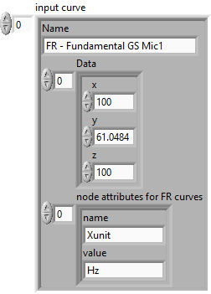

Output:
Output curve (Cluster):
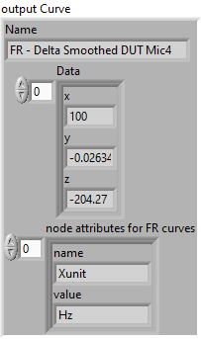
Front Panel:
