windowing vi
- Chop the input curve with a range of frequency to provide an output curve that only contains the data within the frequency range set

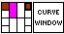
Input:
Windowing (Cluster):
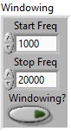
Curve in (Cluster):
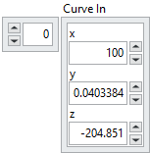

Output:
Curve Out
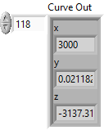

Front Panel:
