Program Manual
- Program interface
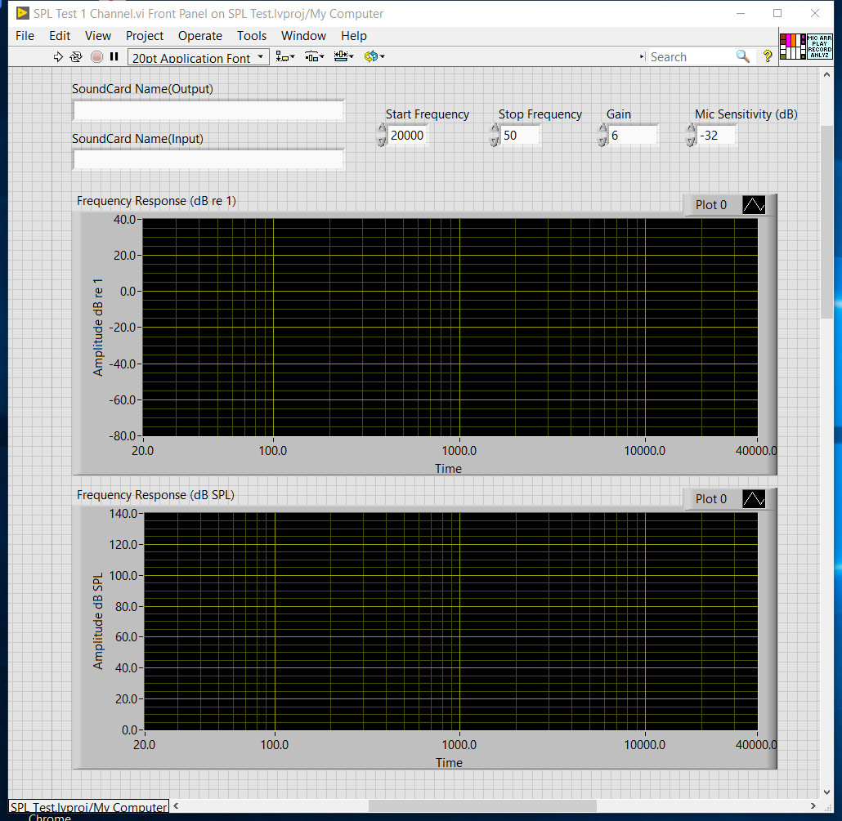
- Soundcard Name(Output)
  - Right click on your Speaker under taskbar and select Sounds
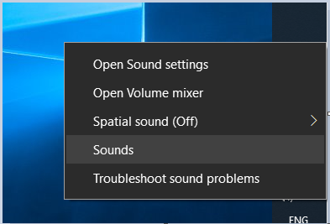
  - At sound setting menu, Select Playback
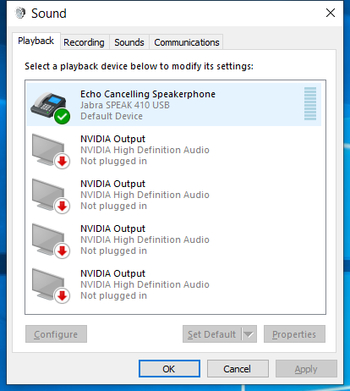
  - Double click the playback device you want to use, Select the name of soundcard then place the same string into “SoundCard Name(Output)

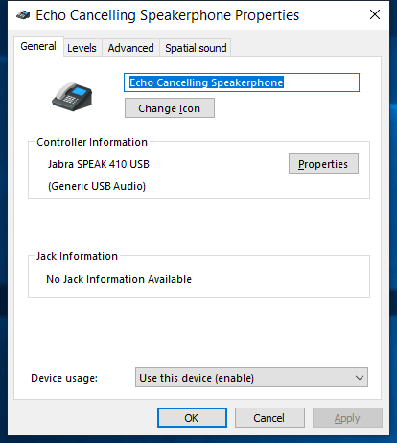

- SoundCard Name Input
  - Select Recording tab at sound setting menu
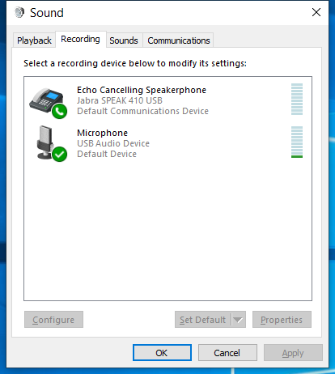
  - Double click the Recording device you want to use, Select the name of soundcard then place the same string into “SoundCard Name(Input)

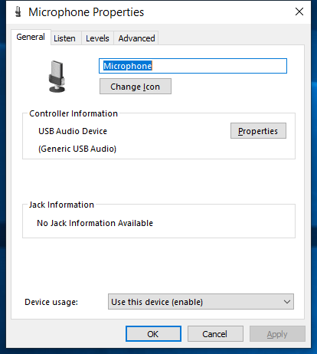

- Once fill up all the soundcard info, the screen should look like this.

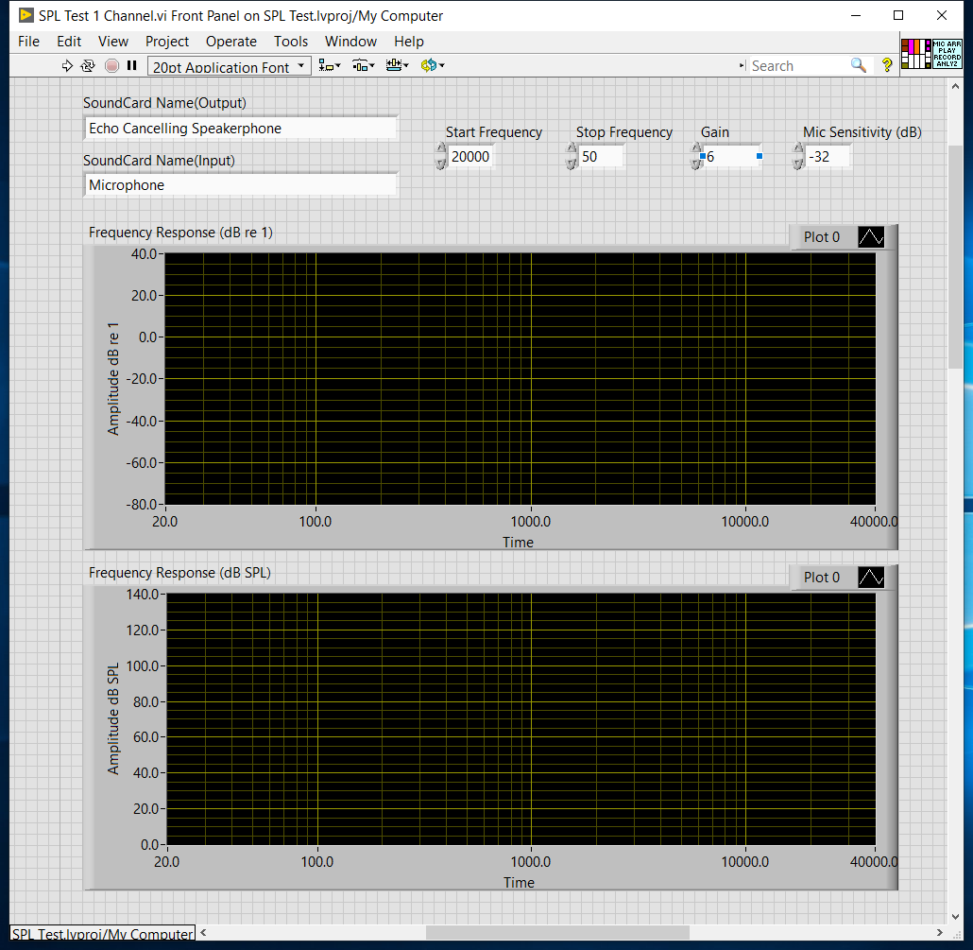

- Test sweep setting
  - Start frequency : Starting frequency you want the sweeping to start
  - Stop frequency : Stop Frequency
  - Gain : This will be the Gain of your amplifier, Smaller the value, higher the signal level
  - Mic Sensitivity : Sensitivity value for your microphone. You should able to get it from datasheet. And only valid when your microphone power supply set the gain to 0. This is only useful if you want to determine the absolute level. If you do not care about the absolute level and only looking for relative level. You can just use the default -32dB which is most of the microphone in the market using now.

