savewavefile vi
- Export waveform to wave file

Input:
Waveform path (path): directory path to store wave file
SN (string): DUT SN use for wave file naming purpose
Waveform in (waveform): waveform data to export
Sound format (cluster): information to generate wavefile
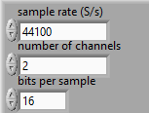

Front Panel :
