Recall_Dat vi
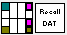

Input
dat file(path): file path for dat file

Output:
Curve (cluster): imported curve from dat file
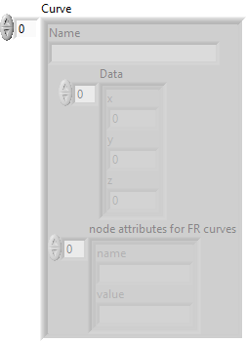
All data (array string): display all data form dat file
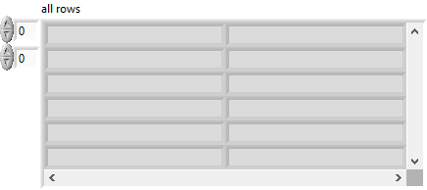

Front Panel:
